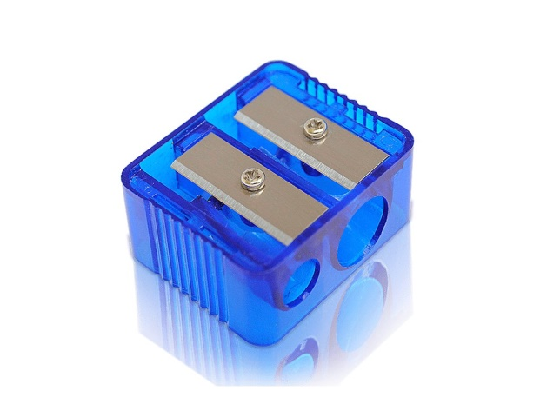Doplň věty *(použij druhý stupeň od přídavných jmen „old, new, small, big, happy, sad)*

The red sharpener is ……………… than the blue sharpener.

The blue sharpener is ……………… than the red sharpener.

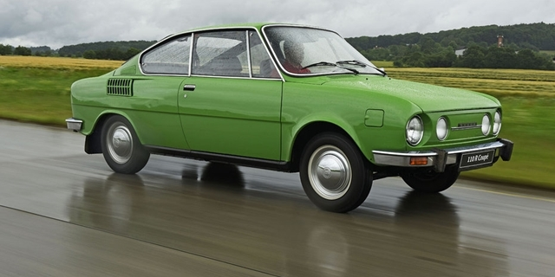 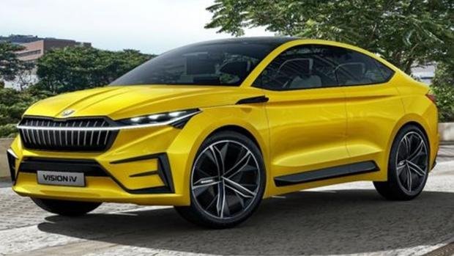

The green car is …………………… than the yellow car.

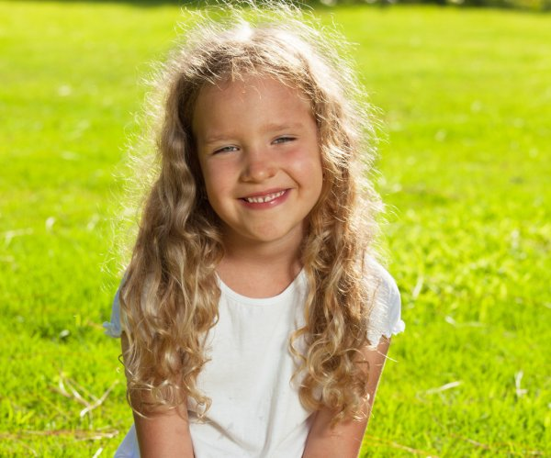The yellow car is ………………….. than the green car.



The girl is ……………

than the boy.

The boy is ………..….

than the girl.