[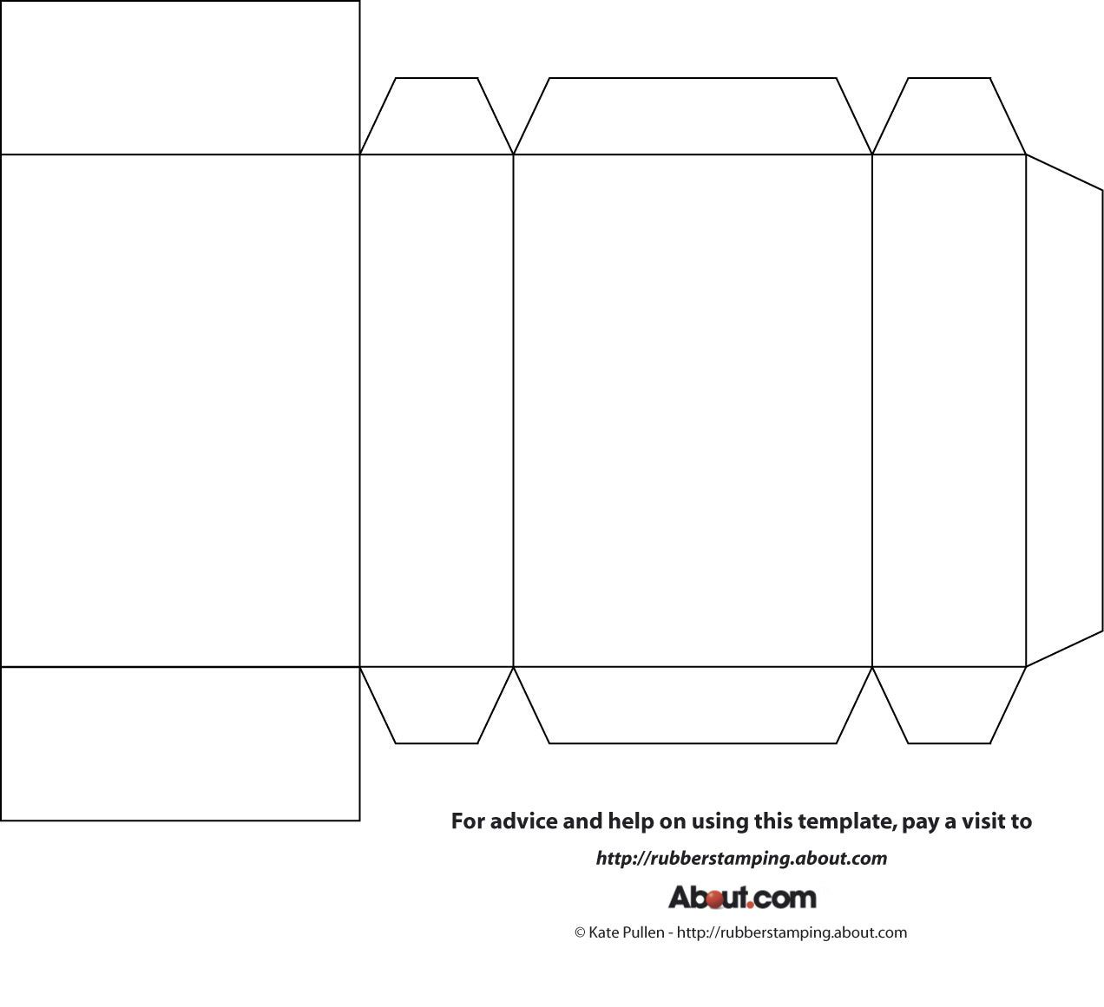](https://www.google.cz/url?sa=i&url=https://www.pinterest.com/pin/519110294520724274/&psig=AOvVaw3zT5k_99Ph3YxvA6IRmyZI&ust=1584956632861000&source=images&cd=vfe&ved=0CAIQjRxqFwoTCMDT6fblregCFQAAAAAdAAAAABAi)